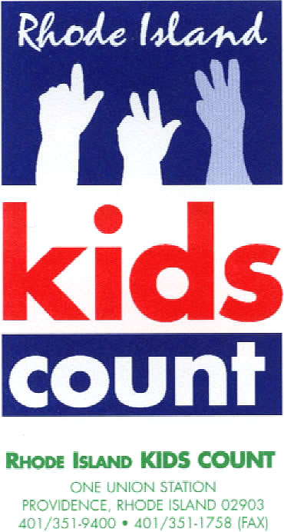
Contact: Katherine Linwood Chu, Communications Manager
401.351.9400, Ext. 22 / kchu@rikidscount.org

Rhode Island KIDS COUNT
Celebration of Children’s Health

Event celebrates the progress Rhode Island has made in increasing access to high-quality health coverage — Rhode Island is ranked 2nd best in the nation for children’s health coverage

Recommendations for how Rhode Island can improve access to health care and improve health outcomes among Rhode Island children presented
Providence, RI (November 13, 2020) – About 200 community leaders, elected officials, and health care advocates will gather virtually on November 16, 2020 for the 20th annual Celebration of Children’s Health to reflect on the progress that Rhode Island has made in achieving positive health outcomes for children — including the fact that Rhode Island is now ranked second best in the nation for children’s health coverage.

To join the event on Monday via Zoom, please click here.

Covering Kids Awards
Jennifer Jencks, Ph.D., Director of the Access Center at Bradley Hospital, and Central Falls Mayor James A. Diossa are this year’s recipients of the Covering Kids Award. Dr. Jencks oversees Kids’ Link RI, a 24/7 hotline for parents and caregivers seeking information on behavioral health services for children and youth in crisis. She is being honored for the work she is doing to ensure that children and families have access to critical mental and behavioral health services during the COVID-19 pandemic. Central Falls Mayor James A. Diossa is being presented an award for his leadership in putting the health and well-being of Central Falls' children front and center during his time as mayor and for his strong advocacy on race equity, meeting the health needs of immigrant children and their families, and the 2020 Census.

Serena Simeone will share her perspective as a RIte Care member.
Governor Gina Raimondo, Senator Jack Reed, Senator Sheldon Whitehouse, Congressman James Langevin, Representative Joe McNamara, and Senator Josh Miller will share federal and state perspectives on increasing access to children’s health insurance coverage and health care.

Rhode Island KIDS COUNT will highlight new data from the U.S. Census Bureau’s 2019 American Community Survey (ACS). The ACS provides national and state-level data on health insurance coverage. The latest data shows that 98.1% of Rhode Island’s children under age 19 had health insurance coverage, and that Rhode Island is ranked second best in the nation for children’s health insurance coverage. In 2019, 51% of Rhode Island children had health coverage through a parent’s employer, and 33% of Rhode Island children had health coverage through RIte Care. Of Rhode Island children, 7% are covered through a combination of insurance types, 6% through direct purchase, and 1.9% of Rhode Island's children are uninsured.

Data includes private coverage and public coverage, including Medicaid/CHIP (known as RIte Care in Rhode Island). Rhode Island has maintained health insurance coverage for children while the nation has seen a marked loss of coverage (from 95.5% in 2016 to 94.3% in 2019).

COVID-19 – Immediate Impacts and Increasing Inequity
In Rhode Island, the COVID-19 pandemic is disproportionately impacting our Latino community. Black and Hispanic households are projected to face the greatest increase in poverty, and racial and ethnic disparities may be exacerbated for children and families of color.

“In addition to collecting data on the scale and nature of the impact on children, expanding public assistance programs that meet the immediate needs of families with a focus on equity will help inform policymakers and mitigate the impact of the pandemic on our most vulnerable children and families,” said Katie Orona, MPH, Rhode Island KIDS COUNT Policy Analyst.

Since the onset of the COVID-19 pandemic, many Rhode Islanders have experienced a loss of employment. Loss of employment in low-income households is expected to impact economic mobility and have devastating long-lasting effects on children's economic well-being and health. With 55% of Rhode Island children currently accessing health care through their parent’s employer-based coverage, many families are currently at risk of losing their coverage and access to health care.

Recommendations
To further improve the health of children in our state – and to prevent the worsening of disparities, or increasing negative health outcomes – Rhode Island KIDS COUNT recommends that Rhode Island:
- Cover all kids regardless of immigration status
- Provide twelve months of continuous eligibility for postpartum women
- Address the impact of COVID-19 by expanding public assistance programs to meet the needs of families and children with a focus on equity
- Close racial/ethnic disparities across health indicators with a focus on maternal and infant morbidity/mortality
- Expand access to community-based doula services through Medicaid and commercial insurance
- Provide comprehensive mental health services in schools and community-based settings
- Continue to focus on patient-centered care for children and families
- Take advantage of the opportunity of the First 1,000 Days of RIte Care

Rhode Island’s Positive Health Outcomes for Children

Rhode Island also leads the nation in many children’s health outcomes:
- Adolescent HPV Vaccination (1st)
- Children’s Health Coverage (2nd)
- Child & Teen Deaths (1st)
- Teen Births (6th)

RIte Care’s National Excellence

RIte Care is a Top-Quality Performer in the following areas, according to the U.S. Department of Health and Human Services:
- Primary Care Access and Preventive Care
- Maternal and Perinatal Health

The National Committee on Quality Assurance (NCQA) evaluates and rates Medicaid plans across the country. In 2020, only two Medicaid plans in the country received a NCQA rating of 4.5 or higher -- including RIte Care (which is offered through Neighborhood Health Plan of RI, Tufts, and United Healthcare). Rhode Island is fortunate that Neighborhood Health Plan of RI, Tufts and UnitedHealthcare are regularly among the highest-rated Medicaid health insurance plans in the nation.

Elizabeth Burke Bryant, Executive Director of Rhode Island KIDS COUNT, emphasized, “ Today we have much to celebrate, but we also have work to do to make sure that our progress with health insurance coverage and health outcomes continues especially now during the COVID-19 pandemic when having access to health care is more important than ever and when many families are losing employment and with it their employer-sponsored health insurance.”

###
Rhode Island KIDS COUNT is a statewide children’s policy organization that works to improve the health, economic well-being, safety, education, and development of Rhode Island children.

